ME(7) Course

1. C (Raspberry Pi)
2. Python (Raspberry Pi)
3. Serial Port (RS-232)
4. VB.NET
5. WAMP, LAMP (HTML, MySQL, PHP)
6. PHP web services
7. Android JSON
8. Project - Home Automation

GNU gcc in Windows (Student Guide)

[](http://1.bp.blogspot.com/-STZAJGaUyis/VZZB6OXS0LI/AAAAAAAAAJs/iJ0N7JPwQfE/s1600/gnu-gcc.png)

1. Install MinGW (gcc for windows)  <http://sourceforge.net/projects/mingw/files/latest/download>
2. Add C:\MinGW\bin to path[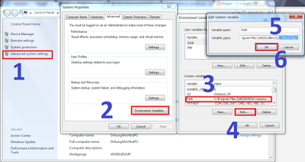](http://2.bp.blogspot.com/-D_770mZ4my0/VZZDT6SWTpI/AAAAAAAAAJ4/7tXHBVENP5g/s1600/path.png)
3. Download Sublime Text 2 Free   <http://www.sublimetext.com/2>
4. creat a new Build System as follow Tools>Build System> New Build System[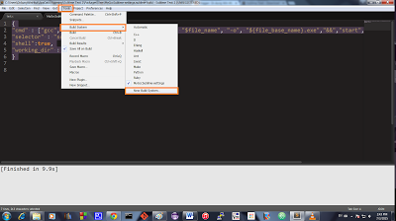](http://4.bp.blogspot.com/-yv9JWhPPr3k/VZZEa57U3sI/AAAAAAAAAKA/UJsMDwxX-Qw/s1600/sublime%2Bsetting.png)[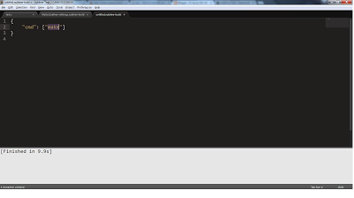](http://3.bp.blogspot.com/-oDEo4BPtcwE/VZZGDF9JpSI/AAAAAAAAAKM/FX56KUWXOFw/s1600/sublime%2Bnew%2Bbuild%2Bsystem.png)
5. copy and past following {

"cmd" : ["gcc", "-Wall","-ansi", "-pedantic-errors", "$file_name", "-o", "${file_base_name}.exe","&&","start","cmd","/k","$file_base_name"],

"selector" : "source.c",

"shell":true,

"working_dir" : "$file_path"

}

1. Save it and Now you can build your codes!!!